Mobile worker help—Use ArcGIS Field Maps to collect data

This file is designed to make it easier for you, the admin or project manager, to create a single page reference sheet for your mobile workers using Field Maps. It doesn’t include setup information, but instead focuses on tasks that might be needed during a field operation. Other than the first part walking you through customizing the information for your workflow and needs, the contents are written for the mobile worker. Take it, customize it, make it your own (add your logo, etc), and share it with your workers. There are versions of the printable guide for both Android and iOS devices.

How to use this document
- Replace <<MAP NAME>> with the name of the map or map area your workers will be using. If using this sheet across projects, delete <<MAP NAME>>. If not using a map area, delete “Tap the map area.”
- Use terminology familiar to your workers:
  - Replace instances of “asset” with “observation” or another word specific to the type of information you are collecting, if asset isn’t correct for your project.
  - Replace instances of “report” with another word specific to the type of inspection you are collecting, if report isn’t correct for your project. If it has location and a form, “asset” may be more appropriate.
- Delete sections that don’t apply to your workers:
  - If they don’t use related records, delete the section Inspect and add a related report.
  - If they don’t update existing assets, delete the section Inspect and update an existing asset.
  - If they don’t delete assets, delete the section Delete.
  - If they don’t create or update asset locations (geometry), delete the section Quick reference – Asset location tools. Also delete the following steps:
    - Capture a new asset > Step 3
    - Inspect and update an existing asset > Step 5
    - Inspect and add a related report > Step 7
  - If they don’t work offline, delete the section Sync as well as the troubleshooting tips marked (if working offline)

- Update the sign in section as follows:
  - Replace <<ORG NAME>> with your ArcGIS organization’s name.
  - Update step 2 to only talk about ArcGIS Online or ArcGIS Enterprise, whichever your organization uses.
  - Update step 3:
    - If using ArcGIS Online, delete step 3.
    - If using ArcGIS Enterprise and a providing a barcode or QR code for users to scan to sign in, replace <<IMAGE OF YOUR CODE>> with an image of your code and update the step to only talk about scanning that code.
    - If using ArcGIS Enterprise and having users type in the URL, replace <<ORG URL>> in step 3 with your ArcGIS organization’s URL and update the step to only talk about specifying the URL.
  - If using ArcGIS accounts, update step 4 (“Enter your credentials”):
    - Replace <<USER NAME>> with the name the user will sign in with (this should be unique per worker). If the user already has this information, delete “Username: <<USER NAME>>” from step 4.
    - Replace <<PASSWORD>> with the password associated with the user’s account. If the user already has this information, delete “Password: <<PASSWORD>>” from step 4.
  - If using your company’s accounts:
    - If used with ArcGIS Online, add a new step 3 (after “Tap Sign in with ArcGIS Online”) that reads: “Tap Enterprise login.” Add another step after that one, “Type in <<ORG URL START>> and tap Continue.” where <<ORG URL START>> is the part of your organization’s url before “.maps.arcgis.com”
    - Provide steps to take your user through your company’s sign in process. Include information about the username and password that should be used: for example, if the username follows a pattern like employee ID followed by @mycompany. Include information about the password that is used: for example, if it is the same password as used to sign in to their computer, or a specific company system.

- Review, address, and delete all yellow highlighted text: it is used to call your attention to places where you need to make choices or add or remove information. Look for those throughout the sheet, and make sure none are left when you pass this to workers.

- Specifying a different collection workflow than the default (at your location with an empty form)
The first step in Capture a new asset assumes your mobile workers use the GPS and collect new assets with empty forms. If that isn’t the case for your mobile workers, replace Tap Add (on the map). with the following, as appropriate for your workflow:
  - If your mobile workers copy the form from another asset to their location, replace it with:
(Android) View the form of the asset to copy, swipe up on the panel (or tap Overflow below the panel), and tap Copy.
(iOS) View the form of the asset to copy, swipe up on the panel (or tap Overflow below the panel), and tap Copy.
You’ll also want to remove any other steps (updating attributes or geometry) that the mobile worker doesn’t do since information was copied from another feature.
If the asset is read-only or only supports attribute editing, this copies the form and location of the asset to a new asset.
- If your mobile workers create an asset at a location chosen on the map, replace it with:
Long press the map to drop a pin and tap Collect here.
- If your mobile workers create an asset by providing the coordinates at which to place it, replace it with:
Search for the coordinates and tap Collect here.
- If your mobile workers create an asset at the same location as an existing asset and use an empty form, replace it with:
(Android) View the form of the asset of which you are using the location, swipe up on the panel (or tap Overflow below the panel), and tap Collect here.
(iOS) View the form of the asset of which you are using the location, swipe up on the panel (or tap Overflow below the panel), and tap Collect here.
If an asset is read-only or only supports attribute editing, your mobile workers can use it to create a new asset at the same location and with the same form. Replace the step with:
(Android) View the form of the asset to copy, swipe up on the panel (or tap Overflow below the panel), and tap Copy.
(iOS) View the form of the asset to copy, swipe up on the panel (or tap Overflow below the panel), and tap Copy.
You’ll also want to remove any other steps (updating attributes or geometry) that the mobile worker doesn’t do since information was copied from another feature.
If the asset isn’t read-only or attribute-only editing, this copies the form (but not location) to a new asset at the mobile worker’s location.

- Make sure the page layout looks good. Try to keep sections in a single column (not spilling over into the next) by keeping the text you add concise, and by moving sections around on the page.

ArcGIS Field Maps Reference Sheet
For iPhone and iPad
Open the map <<MAP NAME>>
In the list of maps, tap the map. (if offline map area) Tap the map area.

Capture a new asset
- Tap Add (on the map).
- (if multiple types) Choose the type of asset to capture. Provide info on the type to use.
The asset (or its first point, if a length or area) is placed on the map at your location.
- Update the asset’s location (if necessary) or add additional points for a length or area using Asset location tools. Provide requirements here: must use GPS, must stream, etc.
- Fill out the form – tap an entry to select it and enter the information.
- (if adding attachments) Tap Take Photo to take and add a photo or tap Attach if attaching an existing item. Long press an attachment to rename it, save it to your device, or remove it from the asset.
- Tap Submit.

View a form
- Tap the asset on the map or search for it to show its form. If multiple assets are found, select the one you want from the list.
- Swipe the panel up to view more of the form. This includes entries, attachments, and related reports and assets.
- Scroll or tap Overflow at the bottom of the form to access all the available actions (edit, copy, delete, collect here, directions, compass, add to my places).

Inspect and update an existing asset
- View the form of the asset to inspect. (Tap it or search for it.)
- Tap Edit in the available actions. (If viewing the asset’s attachments, first tap Details to see the available actions.)
- (if editing attributes) Update the form by tapping an entry to edit it.
- (if editing attachments) Tap Take Photo to take and add a photo or tap Attach if attaching an existing item. Long press an attachment to remove it. Once an attachment is downloaded, long press it to rename it or save to your device.
- (if editing location) Update the asset’s location on the map (use Asset location tools). Provide requirements here: must use GPS, must stream, etc.
- Tap Submit.

Inspect and add a related report
- View the form of the asset to inspect. (Tap it or search for it.)
- In the form, scroll to the Related section. Tap the type of report you are adding (<<RELATED TABLE OR LAYER NAME>>).
- Tap Add.
- Fill out the form – tap an entry to select it and enter the information.
- (if adding attachments) Tap Take Photo to take and add a photo or tap Attach if attaching an existing item. Long press an attachment to rename it, save it to your device, or remove it from the asset.
- (if related asset) Update the related asset’s location (if necessary) or add additional points for a length or area using Asset location tools. Provide requirements here: must use GPS, must stream, etc.
- Tap Submit.

Delete
- View the form of the asset or report to delete.
- Tap Overflow at the bottom of the screen, tap Delete, and choose Delete.
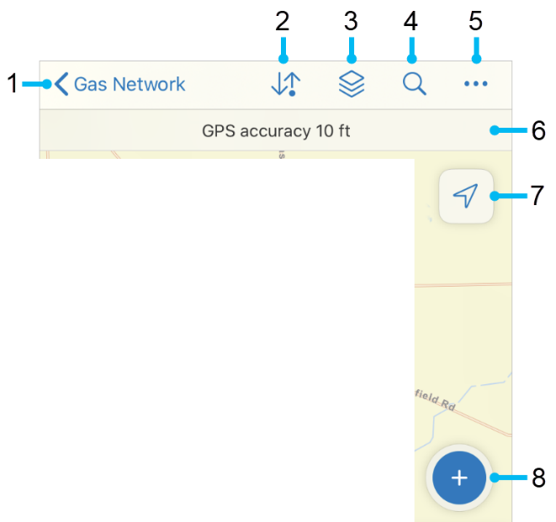
Quick reference – Map tools

- Go back to the list of maps
- Sync
- Layers (visibility, errors, tracking)
- Search (address, place, coordinate, asset) (asset if set in map – provide info on attribute searched)
- Overflow—Change the Basemap , go to Bookmarks, Edit Multiple features, view the Legend, create Markup, Measure on the map, or Share Map.
Tip: Tap on the map to create shapes to measure or use your location.
- See GPS info. Tap for details.
- Go to your GPS location. Tap again to change map orientation.
- Add a new asset.

Quick reference – Asset location tools
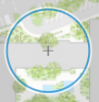
While creating or editing a feature you can edit its location. You’ll see a location target. The target is blue when at your location and the GPS meets required accuracy. When red, the GPS doesn’t meet required accuracy. A gray target is positioned manually (by moving the map).
- Tap Add Point to add a point under the location target. By default, the location target is over your location and moves with you. Move the map to position it manually. Use the GPS button to center it over your location. (With GPS averaging, an average is calculated with each point added with GPS.)
- Use streaming to add multiple points to a length or area automatically while you walk or drive: Tap Overflow and tap Start Streaming. To change the frequency of what points are added, update Streaming Interval in Overflow . Stop Streaming to collect locations manually.
- Tap Update Point (Update Selected Point, in Overflow for lengths and areas) to move the selected point.
- Tap Delete Selected Point, in the Overflow to delete the selected point.
- Use Overflow to undo and redo changes.

Sign in
Sign in to <<ORG NAME>>:
- Open the app.
- Tap Sign in with ArcGIS Online. Or Tap Sign in with ArcGIS Enterprise.
- (If using ArcGIS Enterprise) Tap Scan code and scan the code below:
<<IMAGE OF YOUR CODE>>
Or Tap Specify a New URL, enter <<ORG URL>> and tap OK.
- Enter your credentials:
Username: <<USER NAME>>
Password: <<PASSWORD>>
- Tap Sign In.

Sync (if working offline)
You should sync when you have good connectivity. It’s recommended that you sync whenever you can, and that you enable auto-sync.
- Tap Sync to open the Sync panel. (If there is no dot in the icon, you have no edits to sync.)
- Review the edits you made (if any) and tap Sync.
- Wait for it to complete.

Troubleshooting
- I can’t sign in
- Need to be connected for initial sign in.
- Check for typos in username and password. Password is case sensitive.
- Check for typos in your org URL. remove if not provided
- Can’t add an asset
- Make sure it has a location (check the map).
- Make sure have permissions to edit the data (ask admin).
- Can’t get GPS fix (no location available)
- Go to an open area (away from trees, buildings, etc.) until get a location, then go back to point of interest.
- Make sure Field Maps can use your location (in your device’s settings).
- Get poor location accuracy message and can’t collect a feature.
- Wait and see if accuracy improves.
- Override the required accuracy by tapping Add Point.
- Manually place the point with location target.
- (if working offline) Sync failed
- Make sure you have good connectivity.
- Make sure you aren’t in airplane mode.
- Specify a smaller photo upload size in Profile, delete images, and retake them.
- (if working offline) Sync takes forever
- Specify a smaller preferred attachment size in Profile, delete images, and retake them.
- Sync more frequently.
- (if working offline) Enable logging
- See and share information about download and sync issues by enabling logging.
- Go to Profile, choose Troubleshooting, and enable Logging.

ArcGIS Field Maps Reference Sheet
For Android phones and tablets
Open the map <<MAP NAME>>
In the list of maps, tap the map. (if offline map area) Tap the map area.

Capture a new asset
- Tap Add (on the map).
- (if multiple types) Choose the type of asset to capture. Provide info on the type to use.
The asset (or its first point, if a length or area) is placed on the map at your location.
- Update the asset’s location (if necessary) or add additional points for a length or area using Asset location tools. Provide requirements here: must use GPS, must stream, etc.
- Fill out the form – tap an entry to select it and enter the information.
- (if adding attachments) Tap Take photo to take and add a photo or tap Attach if attaching an existing item. Long press an attachment to rename it or remove it from the asset.
- Tap Submit .

View a form
- Tap the asset on the map or search for it to show its form. If multiple assets are found, select the one you want from the list.
- Swipe the panel up to view more of the form. This includes entries, attachments, and related reports and assets.
- Scroll or tap Overflow at the bottom of the form to access all the available actions (edit, copy, delete, collect here, directions, compass, add to my places).

Inspect and update an existing asset
- View the form of the asset to inspect. (Tap it or search for it.)
- Tap Edit in the available actions. (If viewing the asset’s attachments, first tap Details to see the available actions.)
- (if editing attributes) Update the form by tapping an entry to edit it.
- (if editing attachments) Tap Take photo to take and add a photo or tap Attach if attaching an existing item. Long press an attachment to remove it. Once an attachment is downloaded, long press it to rename it or save to your device.
- (if editing location) Update the asset’s location on the map (use Asset location tools). Provide requirements here: must use GPS, must stream, etc.
- Tap Submit .

Inspect and add a related report
- View the form of the asset to inspect. (Tap it or search for it.)
- In the form, scroll to the Related section. Tap the type of report you are adding (<<RELATED TABLE OR LAYER NAME>>).
- Tap Add.
- Fill out the form – tap an entry to select it and enter the information.
- (if adding attachments) Tap Take photo to take and add a photo or tap Attach if attaching an existing item. Long press an attachment to rename it or remove it from the asset.
- (if related asset) Update the related asset’s location (if necessary) or add additional points for a length or area using Asset location tools. Provide requirements here: must use GPS, must stream, etc.
- Tap Submit .

Delete
- View the form of the asset or report to delete.
- Tap Delete in the available actions and choose Delete.
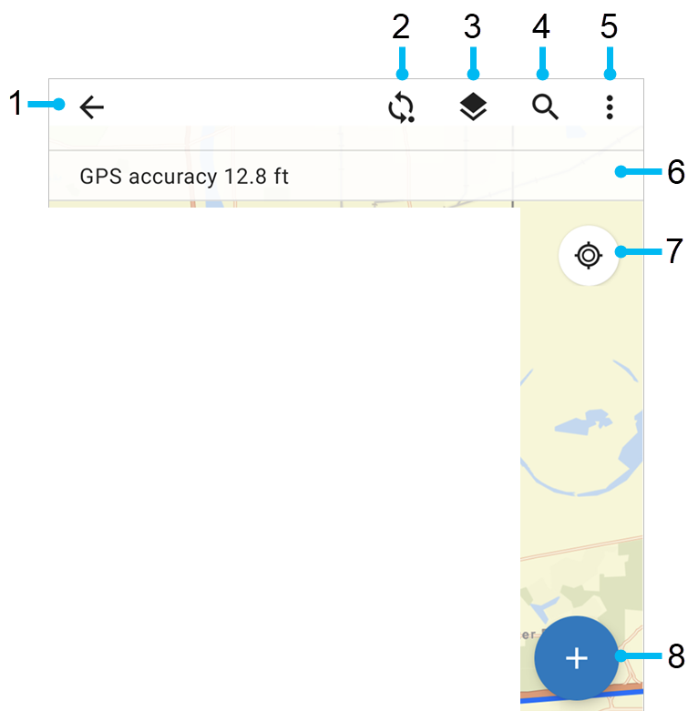
Quick reference – Map tools

- Go back to the list of maps
- Sync
- Layers (visibility, errors, tracking)
- Search (address, place, coordinate, asset) (asset if set in map – provide info on attribute searched)
- Overflow—Change the Basemap, go to Bookmarks, Edit multiple features, view the Legend, Measure on the map, create Markup, or Share map.
Tip: Tap on the map to create shapes to measure or use your location.
- See GPS info. Tap for details.
- Go to your GPS location. Tap again to change map orientation.
- Add a new asset.

Quick reference – Asset location tools
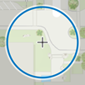
While creating or editing a feature you can edit its location. You’ll see a location target. The target is blue when at your location and the GPS meets required accuracy. When red, the GPS doesn’t meet required accuracy. A gray target is positioned manually (by moving the map).
- Tap Add point to add a point under the location target. By default, the location target is over your location and moves with you. Move the map to position it manually. Use the GPS button to center it over your location.
- Use streaming to add multiple points to a length or area automatically while you walk or drive: Tap Overflow and tap Start streaming. To change the frequency of what points are added, update Streaming interval in Overflow . Stop streaming to collect locations manually.
- Tap Update point (Update selected point, in Overflow for lengths and areas) to move the selected point.
- Tap Delete selected point, in the Overflow to delete the selected point.
- Use Overflow to undo and redo changes.

Sign in
Sign in to <<ORG NAME>>:
- Open the app.
- Tap Sign in with ArcGIS Online. Or Tap Sign in with ArcGIS Enterprise.
- (If using ArcGIS Enterprise) Enter <<ORG URL>> and tap OK.
- Enter your credentials:
Username: <<USER NAME>>
Password: <<PASSWORD>>
- Tap Sign In.

Sync (if working offline)
You should sync when you have good connectivity. It’s recommended that you sync whenever you can, and that you enable auto-sync.
- Tap Sync to open the Sync panel. (If there is no dot in the icon, you have no edits to sync.)
- Review the edits you made (if any) and tap Sync.
- Wait for it to complete.

Troubleshooting
- I can’t sign in
- Need to be connected for initial sign in.
- Check for typos in username and password. Password is case sensitive.
- Check for typos in your org URL. remove if not provided
- Can’t add an asset
- Make sure it has a location (check the map).
- Make sure have permissions to edit the data (ask admin).
- Can’t get GPS fix (no location available)
- Go to an open area (away from trees, buildings, etc.) until get a location, then go back to point of interest.
- Make sure Field Maps can use your location (in your device’s settings).
- Get poor location accuracy message and can’t collect a feature.
- Wait and see if accuracy improves.
- Override the required accuracy by tapping Add point.
- Manually place the point with location target.
- (if working offline) Sync failed
- Make sure you have good connectivity.
- Make sure you aren’t in airplane mode.
- Specify a smaller photo upload size in Profile, delete images, and retake them.
- (if working offline) Sync takes forever
- Specify a smaller preferred attachment size in Profile, delete images, and retake them.
- Sync more frequently.

