Location sharing instructions template for ArcGIS Field Maps

This document is designed to make it easier for you to create an instruction sheet that mobile workers can use to start sharing their location in the Field Maps mobile app. The first page of this document walks you through how to customize the second page, which includes the instructions you’ll share with mobile workers.
Before you customize the instruction sheet, ensure that location sharing is required for the map mobile workers will use. When mobile workers scan a QR code for a map that requires location sharing, they’ll be prompted to start sharing their location. For more information, see Require location sharing.

Customize and share the instruction sheet

- Replace <<EVENT NAME/ORG>> with the name of your event or organization.
- Replace the QR code with the unique QR code generated for your map.
  - The QR code is generated on the Sharing page of the Field Maps web app. See Share the map for details.
- Replace <<MAP URL>> with the unique URL generated for your map.
  - The URL is generated on the Sharing page of the Field Maps web app. See Share the map for details.
- Review the page and make sure you’ve replaced the QR code and all of the highlighted text.
- Print or share the second page of this document with mobile workers so they can start sharing their location with Field Maps.

<<EVENT NAME/ORG>>
Location Sharing Instructions

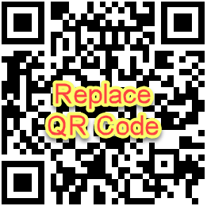

<<MAP URL>>
- Scan the QR Code above using the camera app to install ArcGIS Field Maps on your mobile device. If the app is already installed, skip to Step 2.
- Once installed, scan the QR Code again to open the Field Maps app and sign in with your credentials.
- When prompted, tap the toggle button to turn on location sharing and select the desired duration.
  - Allow Field Maps access to your location if prompted.
  - Allow Field Maps access to use your activity if prompted.
  - Allow Field Maps to send you notifications if prompted.

